
Introduction to Electrical Engineering
Lab Report
Name: Pranesh Chowdhury
ID: 202003112
Course ID: 112
Section: 2
Experiment No: 5
Experiment Name: Verification of Superposition Theorem

Objective:
In this experiment, we verified the superposition theorem. The current through or voltage across an element in a linear bilateral network is equal to the algebraic sum of the current or voltage produced independently by each source. We also measure the two circuits to verify the superposition.
List of Equipment:
- Wires
- Resistors
- PSIM Software
- DC Power Supply
- Ammeters
- Voltmeters
Circuit Diagram:
Circuit 1 - A:
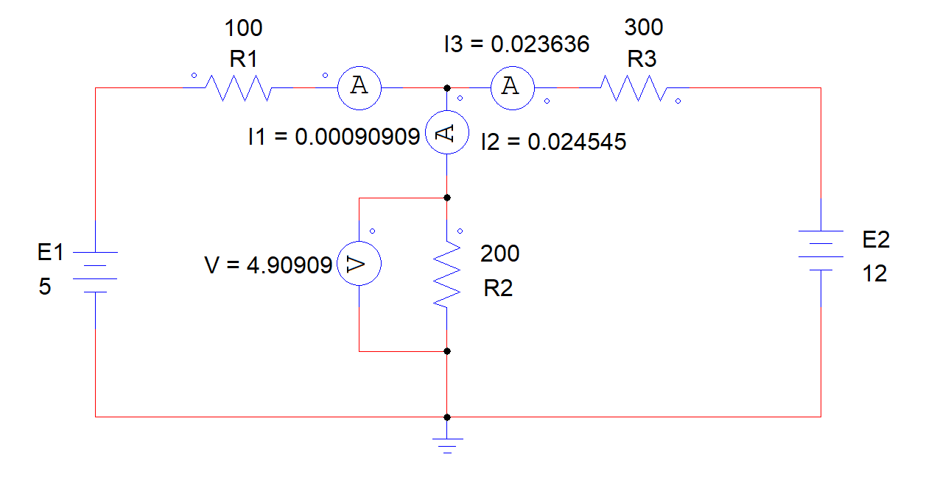
Circuit 1 - B:
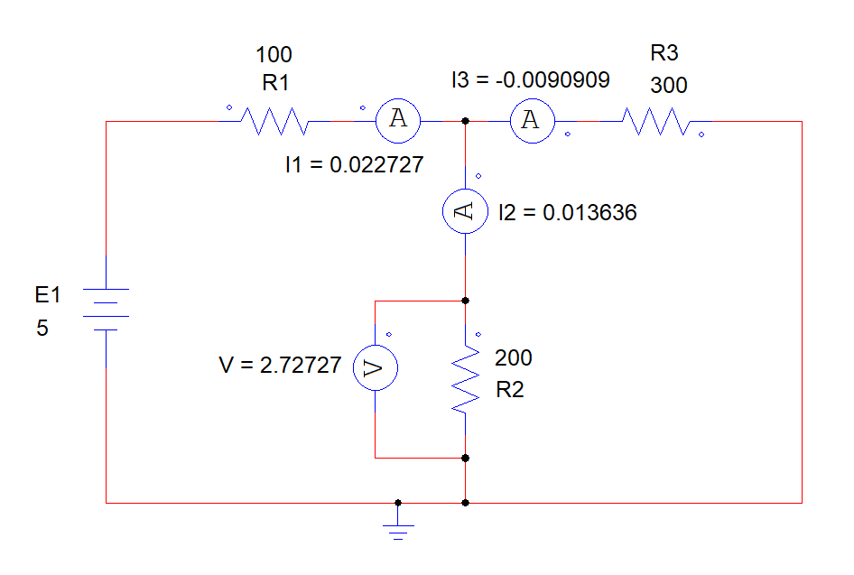
Circuit 1 - C:
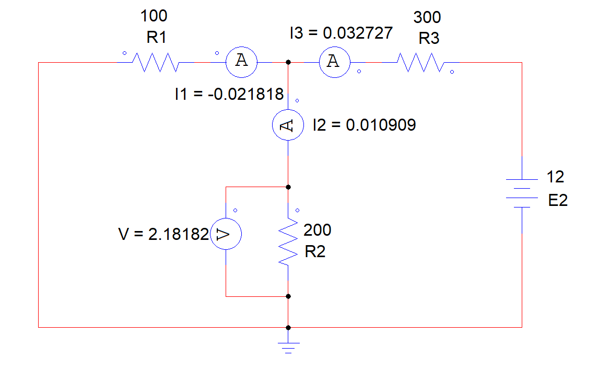
Circuit 2 - A:

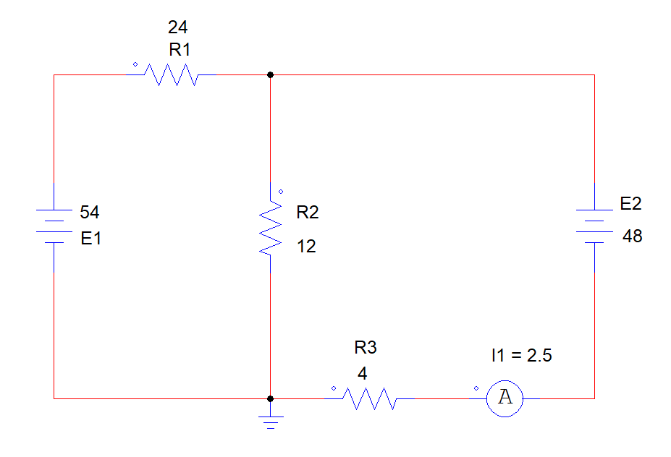
Circuit 2 - B:
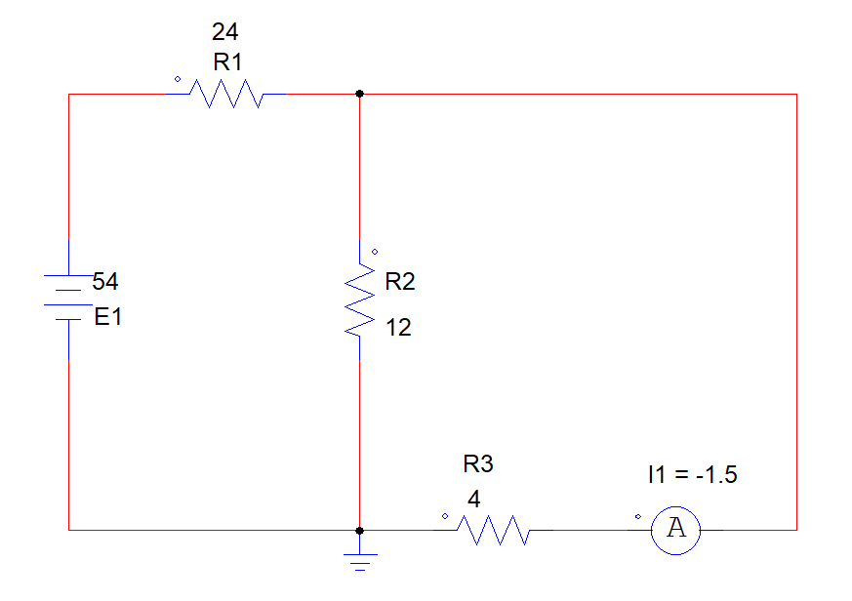
Class 2 – C:
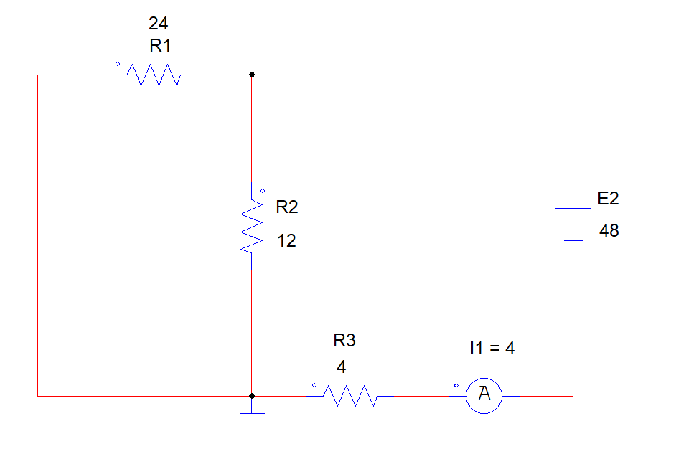
Data Table:
Circuit 1:
I1 | 0.00090909 A | I2 | 0.024545 A | I3 | 0.023636 A | V2 | 4.90909 V
I1’ | 0.022727 A | I2’ | 0.013636 A | I3’ | -0.009090 A | V2’ | 2.72727 V
I1’’ | -0.021818 A | I2’’ | 0.010909 A | I3’’ | 0.032727 A | V2’’ | 2.18182 V

Circuit 2:
I1 | 2.5 A
I1’ | -1.5 A
I1’’ | 4 A

Result:
Circuit 1:
I1 = I1’ + I1’’
- 0.022727 + ( -0.021818) A
- 0.00090909 A
I2 = I2’ + I2’’
- 0.013636 + 0.010909 A
- 0.024545 A
I3 = I3’ + I3’’
- ( -0.009090 ) + 0.032727 A
- 0.023636 A
V2 = V2’ + V2’’
- 2.72727 + 2.18182 V
- 4.90909 V
Circuit 2:
I1 = I2 + I3
- (-1.5) + 4 A
- 2.5 A
Discussion:
In this experiment, we measure two circuit currents and voltage for verifying the superposition theorem. We evaluate the six circuits using PSIM software. We also compare all circuit values and the calculated value is equal so that we can verify the superposition theorem.

